Design of MLP Model
The MLP that I am going to design is a two layered, i.e., Input neuron, one hidden layer and an output layer. To count the number of layers, we should not count the input neuron as input layer.
For this project, I am going to use fully connected network structure with 2 layers: 1 hidden layer and an output layer.
Input layer: For the IRIS dataset, the input layer will have 4 neurons as there are 4 predictors in the dataset. I am using “ReLU” as an activation function.
Hidden layer (First counted layer): This layer is located between the Input layer and the output layer. This receives the signals from the input layer and supplies through an activation function to output layer. In general case, this can be zero, one or more than one.
In our case, I am using only one hidden layer with 8 neurons and using “ReLU” as an activation function for better performance.
ReLU:
The function of ReLU is to remove negative values from an activation map by setting them to zero.
The ReLU function, F(x)=max(0,x), returns x for all values of x > 0, and returns 0 for all values of x ≤ 0.

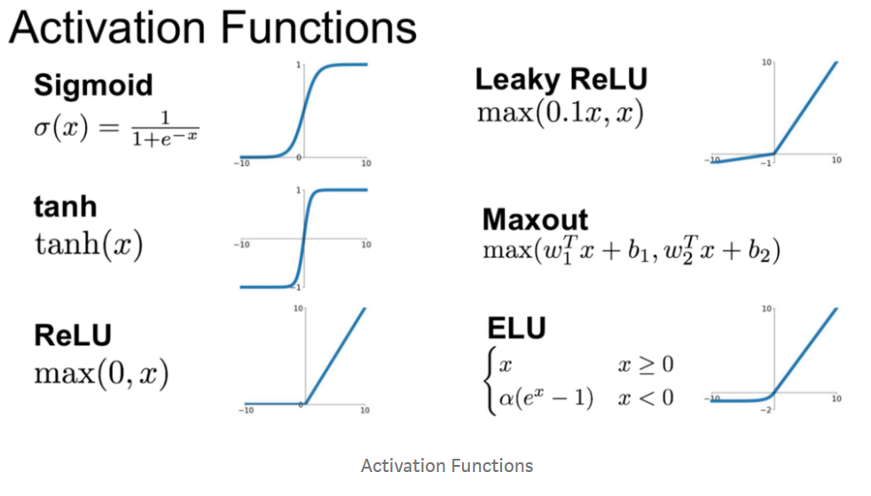
Output layer (Second counted layer): This layer receives signals from the hidden layer. In our output layer, we have three neurons as we have three outcomes (3 types of flowers) from the species variable. In this we are using softmax as an activation function to ensure our network output is between 0 and 1 and easy to map the probability of a class.
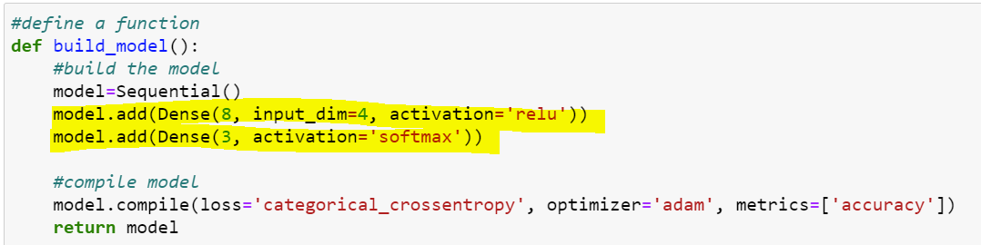
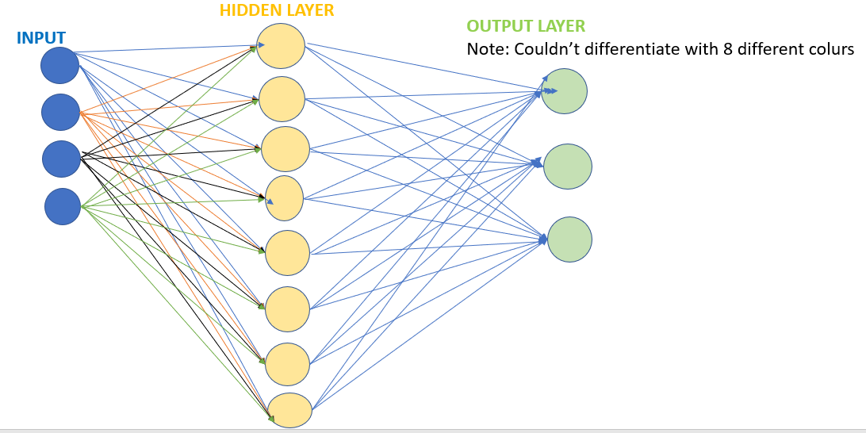
Results:
I have got the accuracy with 98%, which is very good. This is due to the following reasons:
- The Iris data is small and has not many observations.
- 2. The Iris data is clean and can be easily classifiable.
- 3. Less no.of predectors in the Iris dataset, which made easy for the classification.
